Team Members

Nanditha (RA1911003010080)

Rini Ravindran(RA1911003010081)

Chess Game

Problem Statement

Chess is a two-player strategy board game played on a checkered board with 64 squares arranged in an 8×8 square grid. Played by millions of people worldwide, chess is believed to be derived from the Indian game chaturanga sometime before the 7th century.Chess has gained tremendous popularity, and it is leading to a revolutionary trend due to more people getting involved with chess at the time of this global pandemic. So, there is no better time to analyze the role of artificial intelligence in improving the quality of chess.Artificial Intelligence is a revolution in itself with the numerous feats of accomplishments that it has been able to achieve. The use of AI in the real world and real-life scenarios is ample. They have a wide array of use cases to improve the quality of life in general. Another wonderful use of Artificial Intelligence is in the sport of Chess.The Artificial Intelligence algorithms developed for human play utilize many different kinds of principles. The goal is **any board position in which the opponent does not have a legal move and his or her “king” is under attack**. The legal moves provide the way of getting from initial state of final state.

Screenshots

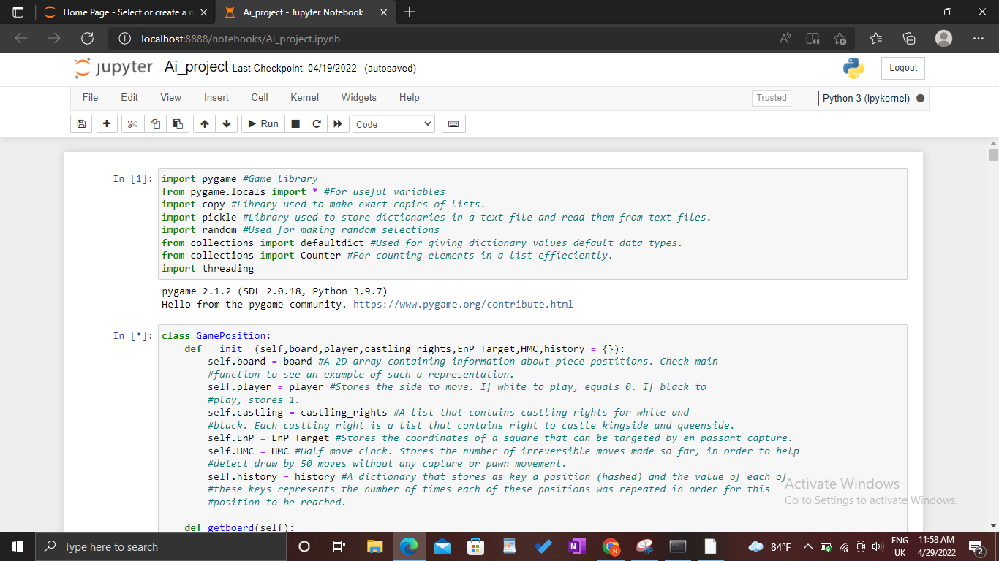

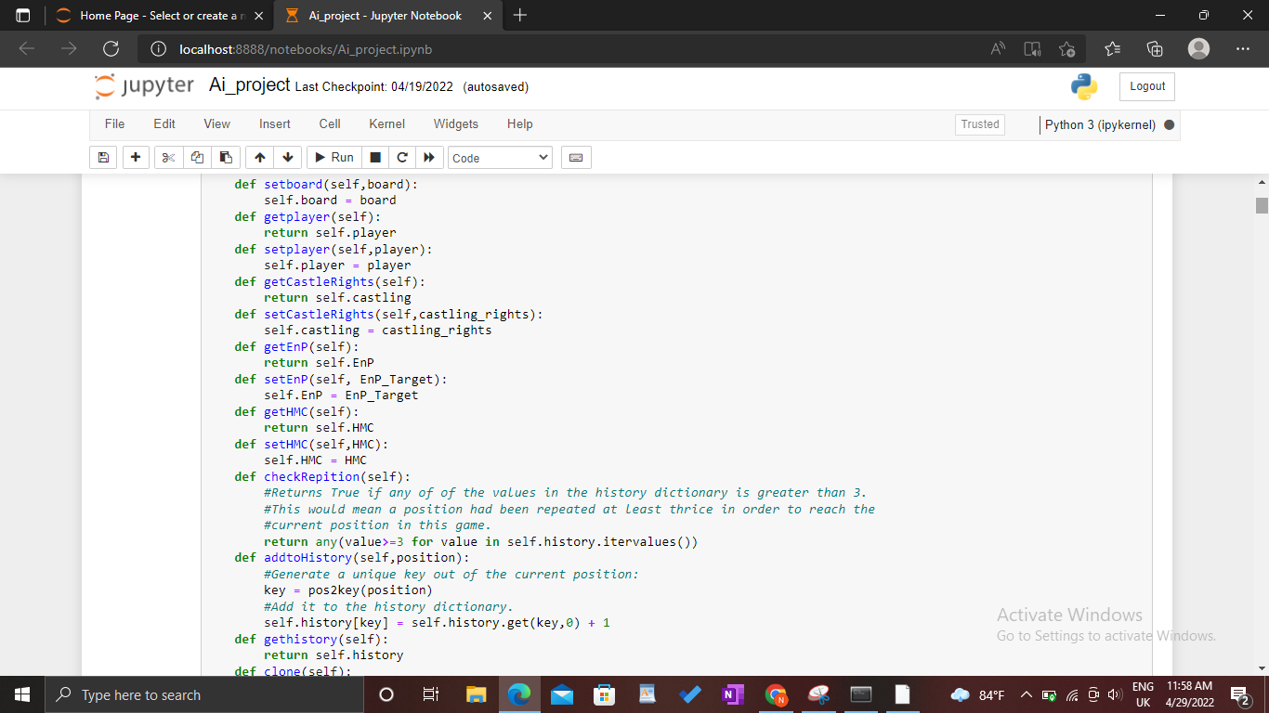

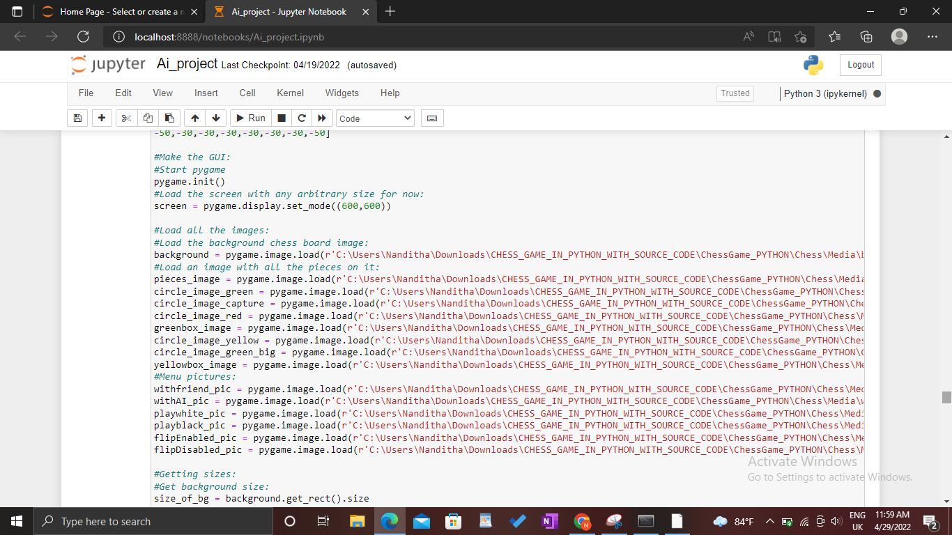

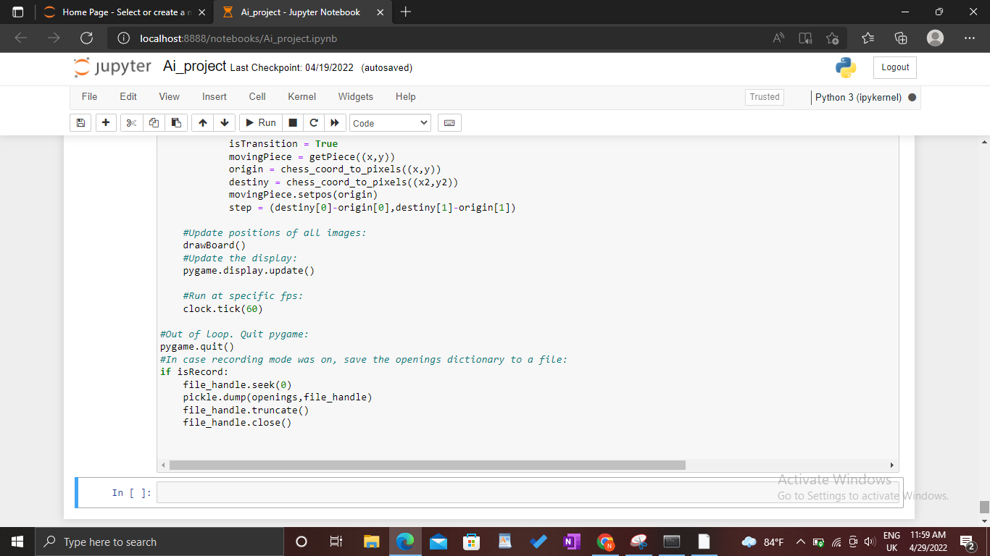

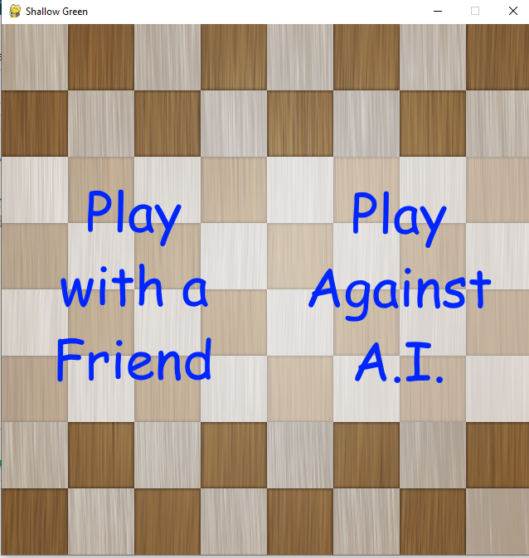

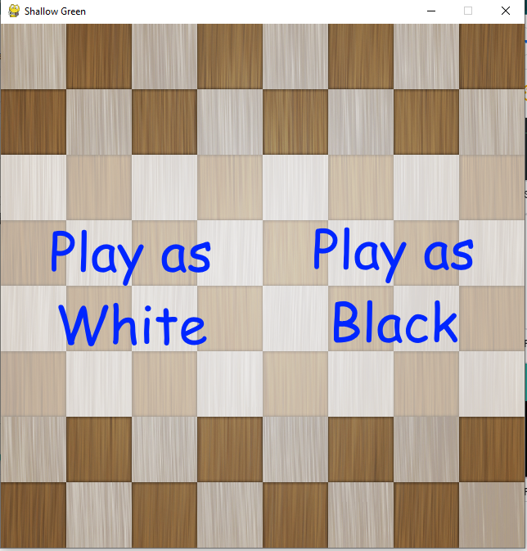

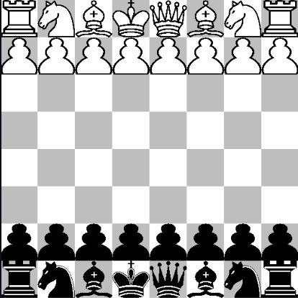

Flowchart

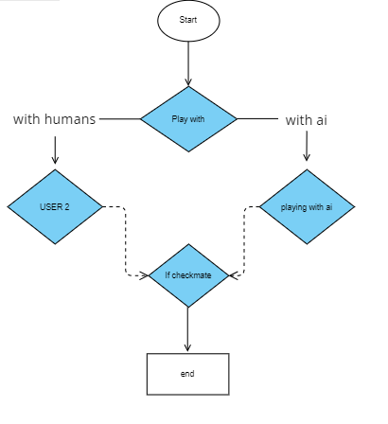

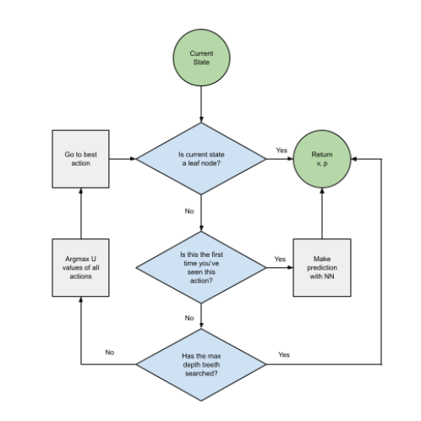

References

<https://towardsdatascience.com/ai-in-chess-the-evolution-of-artificial-intelligence-in-chess-engines-a3a9e230ed50>

https://www.geeksforgeeks.org/design-a-chess-game/